Serverless Development 101

**HOP03 – Create Your First AWS Lambda Function**

1/10/2019 Developed by Kevin Wang

1/10/2019 Checked by Clark Jason Ngo

1/10/2019 Tested by Tuan Khai and Minh Truong

2/10/2019 Revised by Sam Chung

4/9/2020 Reviewed by Apiwat Chuaphan

Center for Information Assurance (CIAE) @City University of Seattle (CityU)



**Learning Outcomes**

* Learn how to create a Lambda function.

**Reference**

* AWS Lambda  
  <https://aws.amazon.com/lambda/>
* AWS Lambda Documentation  
  <https://docs.aws.amazon.com/lambda/latest/dg/welcome.html>
* AWS Lambda Application  
  <https://docs.aws.amazon.com/lambda/latest/dg/deploying-lambda-apps.html>

**The First Lambda API**

1. Open your VSCode
2. Open “myproject” folder.
3. Open the terminal in the VSCode (press control and ~ keys).   
    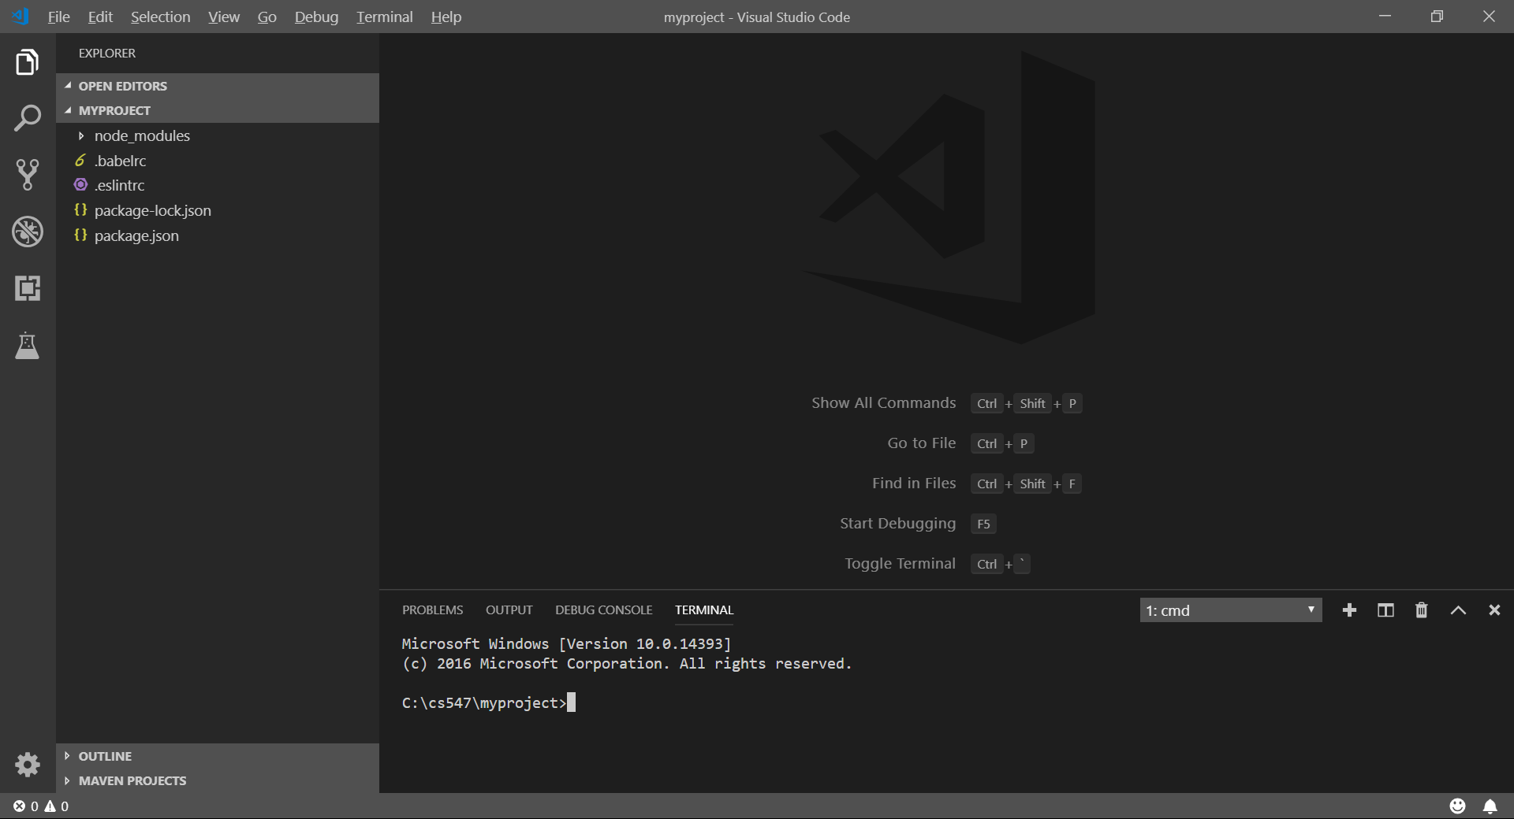
4. Type “serverless create --t aws-nodejs” in the terminal (Make sure you are in the project folder).

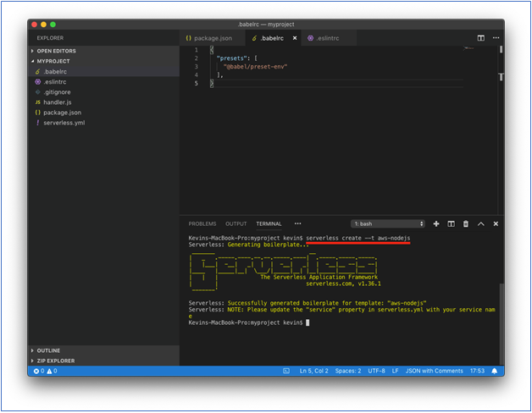   
If you see any update message, update your services.  
For example, you might see a message of updating “serverless.”  
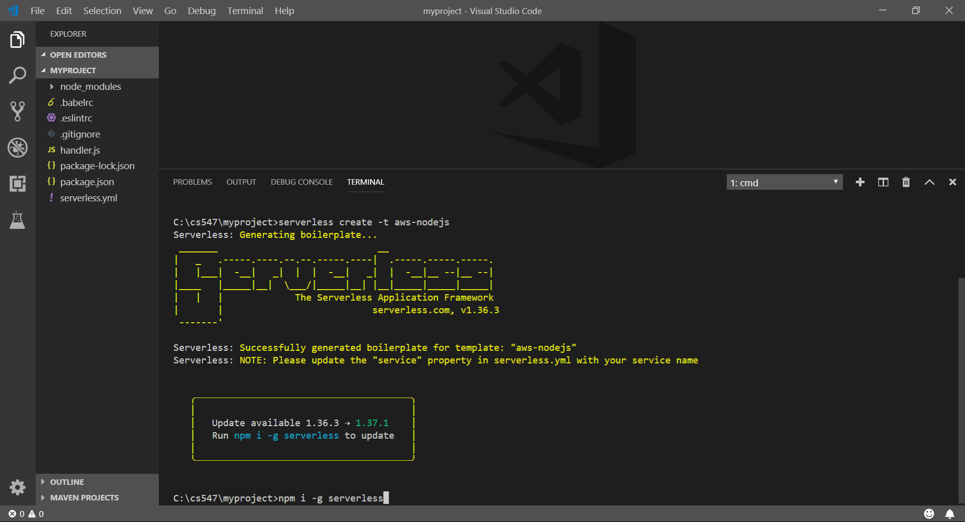

1. Click the “serverless.yml” file in the VSCode   
   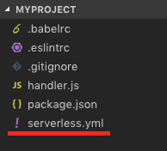 
2. Clear up the contents in the “serverless.yml” and replace with the contents in <https://bit.ly/2Zvhgnc>.  
   Save the file.    
   A screenshot of a cell phone

   Description automatically generated﷟

1. Create a “functions” folder under the root folder   
   (in this picture example below, the root folder is “myproject”).

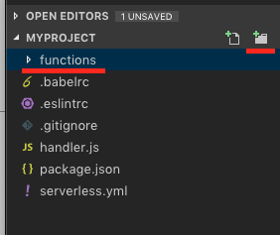 

1. Create a “get-index.js” file under the “functions” folder and copy content from <https://bit.ly/3bZxyal>

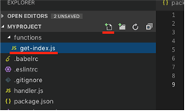   
  
Save the file.

1. Type “sls deploy” in the terminal to deploy the new function.   
   (**It may take a while based on your network speed**.)

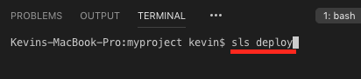   
  
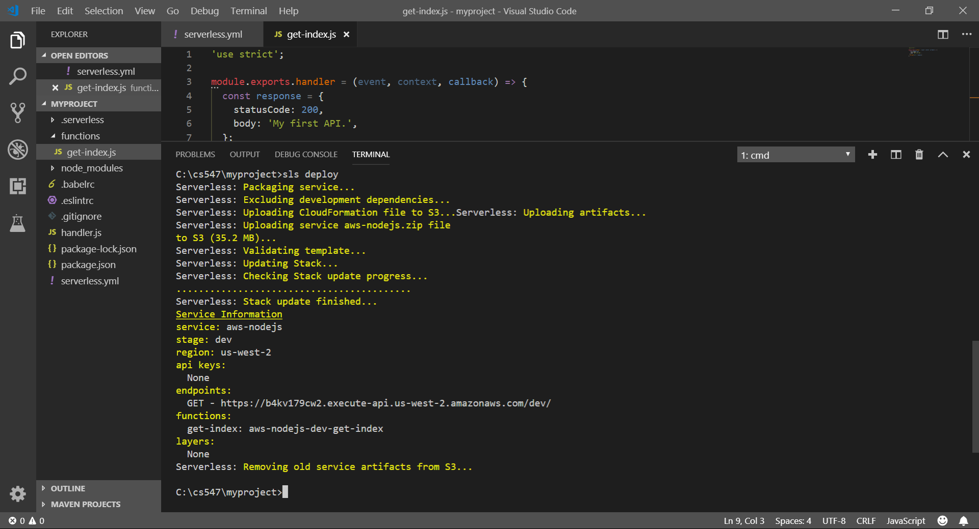  
**Note:** If you get any error regarding the runtime version of Node,js, change runtime in serverless.yml to correct version (ex: **nodejs12.x**) and deploy again.

1. Copy the URL from “endpoints” and put it in the browser to invoke it/var/folders/34/3jns11qs1nd6qd5csswy30mc0000gn/T/com.microsoft.Word/Content.MSO/DFAB27F7.tmp   
   Note: you will have different URL endpoints.   
   Copy this endpoint and open it in the browser’s or press “ctrl+click” to follow link./var/folders/34/3jns11qs1nd6qd5csswy30mc0000gn/T/com.microsoft.Word/Content.MSO/197B8C1D.tmp   
   You should see the text “My first API.” in the browser.    
     
   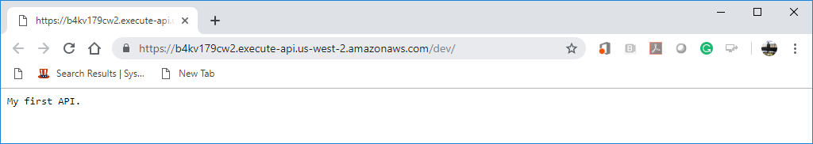
2. Access your “AWS Management Console” and visit your “Lambda” service.  
   Then, visit your Lambda function that you just created.

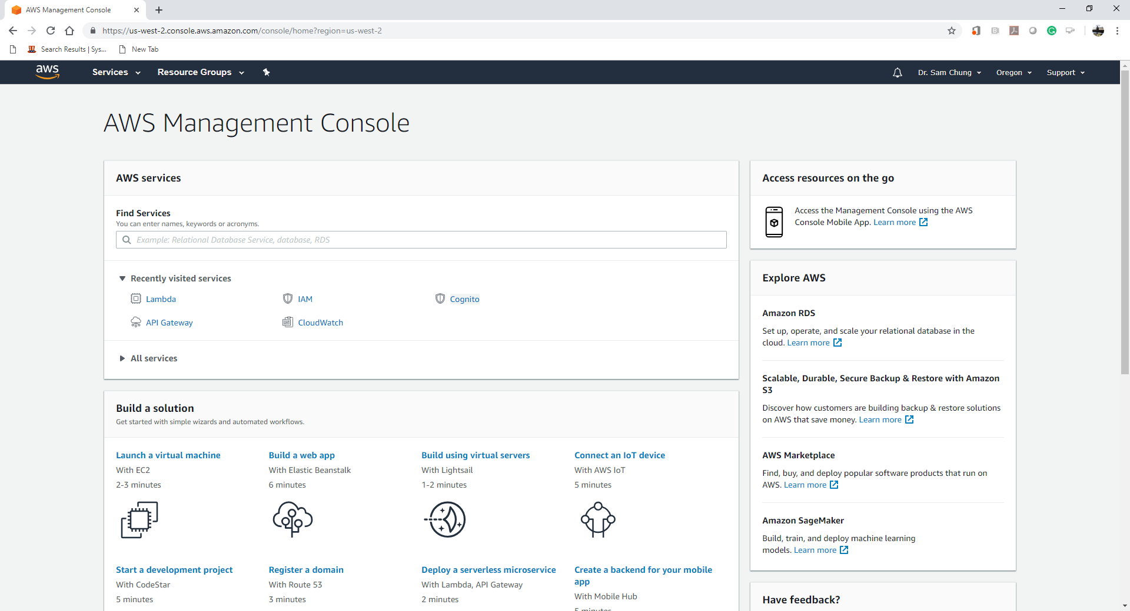

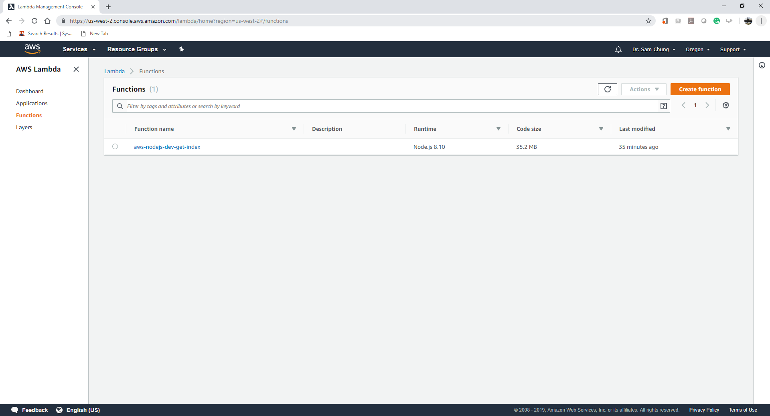

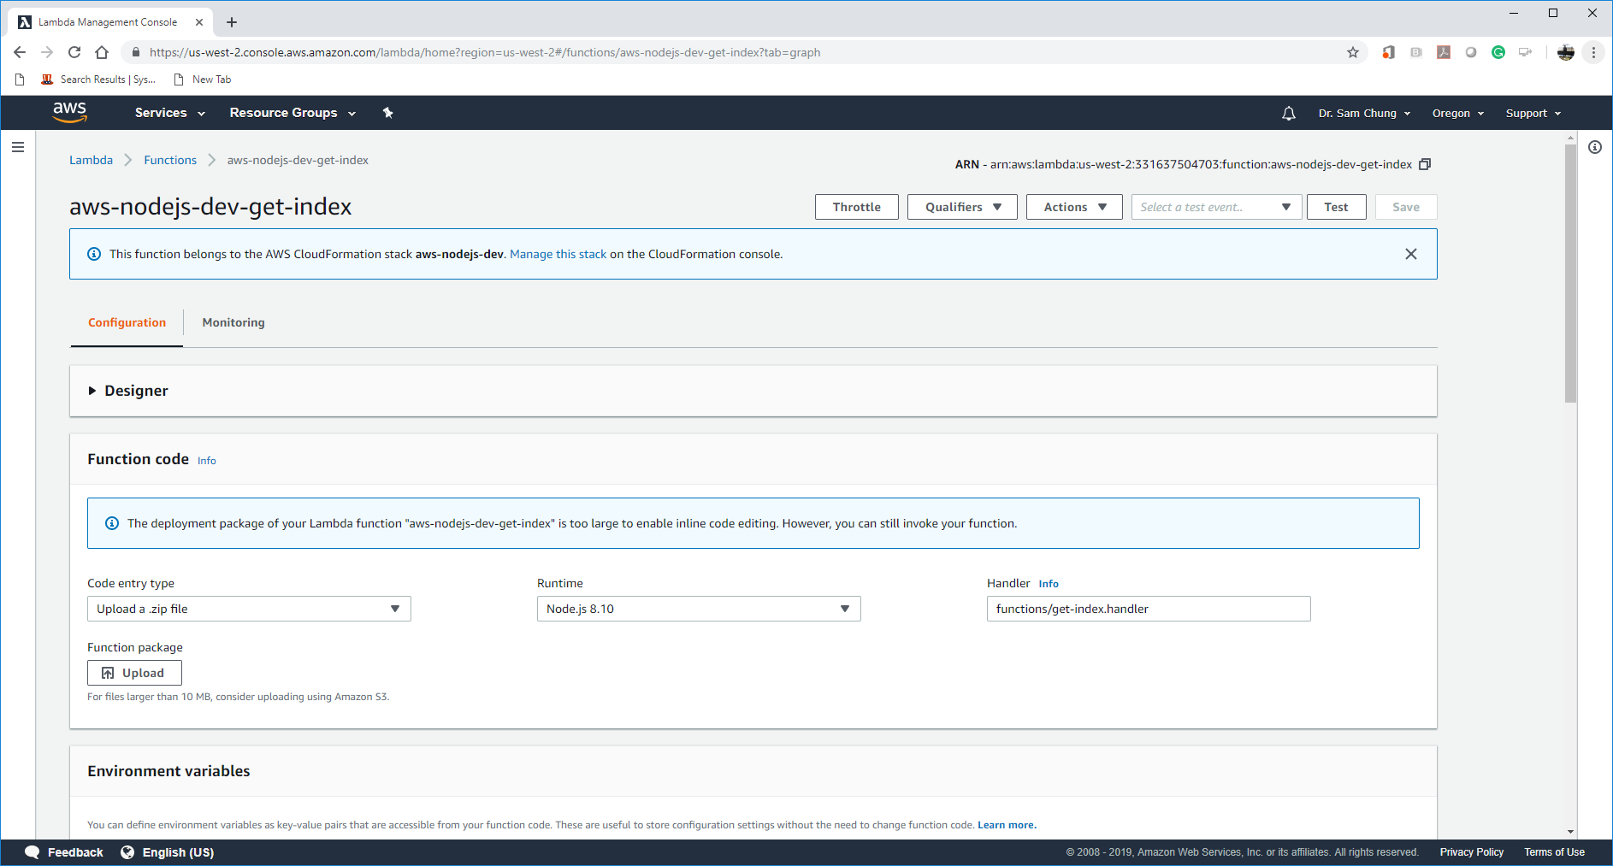

**Push your work to GitHub**

Open the terminal from the VSCode by hit the control + ~ key and type the following command:

Run the following commands to push your work to the GitHub repository:

>>> git add .

>>> git commit -m “Submission for Module 3”

>>> git push origin YOUR_BRANCH_NAME

**Note**: you should change the YOUR_BRANCH_NAME to your own branch name. It should be firstname-lastname (e.g. maria-gracia).

If you cannot remember, run the command “git status” to check